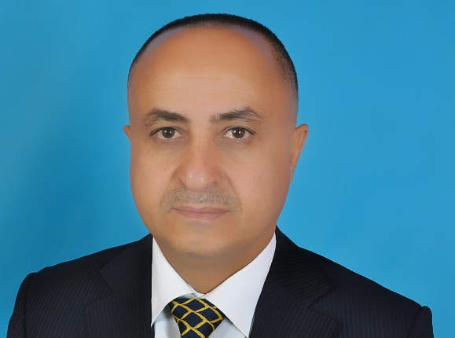

**Personal Information:**

Name: Dr. Yahya Hassan Ismail AL- Matari

Birth Day :7/12/1969

Phone:775055344

Email:yahya206206@gmail.com

**Education:**

* Master's degree of science in Engineering (Radio communications and radiobroadcasting and television) from Moscow technical university of communication and information technology 1995, Moscow-Russia
* Doctor of Philosophy (Ph. D) in Technical Sciences 2006, Vladimir- Russia

**Experience:**

1. Faculty of Mass communication, Sana’a University (2019 – now).
2. Faculty member at the University of Knowledge and Modern Sciences (2020).
3. Faculty member at the Faculty of Humanities - Department of Mass Communication, Iqra'a University for Science & Technology (2018).
4. Deputy Director of the Department of External Transmission (2008).

**Research and scientific papers**:

1. Criteria and methods for assessing the technical indicators of TV images. Methods and devices for transmission and processing of information: Interuniversity collection of scientific papers Issue 4.Methods and devices for transmission and processing of information: Interuniversity collection of scientific papers
2. Методы и устройства передачи и обработки информации: Межвузовский сборник научных трудов.Can't load full resultsTry again

Retrying...

Retrying...

1. Local adaptive algorithms for filtering color images. Design and technology of electronic means, 2004, No. 2, p.Design and technology of electronic means, 2004, No. 2, p.

Конструирование и технология электронных средств, 2004, № 2, с.

Can't load full results

Try again

Retrying...

Retrying...

46-49.

* 46-49.

46-49.

Can't load full results

Try again

Retrying...

Retrying...

1. Filtration of noise from television images in telemedicine. Materials of the VI International Scientific and Technical Conference 2004, Vladimir.Materials of the VI International Scientific and Technical Conference FREMT 2004, Vladimir.

Материалы VI Международной научно-технической конференции FREMT 2004, Владимир.

Can't load full results

Try again

Retrying...

Retrying...

- S.32-33.

* + S.32-33.

- С.32-33.

Can't load full results

Try again

Retrying...

Retrying...

1. Application of vector local filters with adaptation of the aperture size for processing color television images. Methods and devices for transmission and processing of information: Interuniversity collection of scientific papers.Methods and devices for transmission and processing of information: Interuniversity collection of scientific papers.

Методы и устройства передачи и обработки информации: Межвузовский сборник научных трудов.

Can't load full results

Try again

Retrying...

Retrying...

- Issue 5 / Ed. 2004.- p. 149-154.- Issue 5 / Ed.- Выпуск 5 / Под ред.

Can't load full results

Try again

Retrying...

Retrying...

* + SPb .: Gidrometeoizdat, 2004.- S. 149-154.

- СПб .: Гидрометеоиздат, 2004. - С. 149-154.

Can't load full results

Try again

Retrying...

Retrying...

1. Adaptive image contrast enhancement. Materials of the VI International Scientific and Technical Conference 2004, Vladimir.Materials of the VI International Scientific and Technical Conference FREME '2004, Vladimir.

Материалы VI Международной научно-технической конференции FREME '2004, Владимир.

Can't load full results

Try again

Retrying...

Retrying...

- S. 197-198.

* + S. 197-198.

- С. 197-198.

Can't load full results

Try again

Retrying...

Retrying...

1. Comparison of European and American Digital Terrestrial Television Standards. Materials of the VII International Scientific and Technical Conference Materials of the VI International Scientific and Technical Conference.

Материалы VI Международной научно-технической конференции.

Can't load full results

Try again

Retrying...

Retrying...

Advanced technologies in the means of information transmission - Advanced technologies in the means of information transmission - ПТСПИ-2005.

Передовые технологии в средствах передачи информации - ПТСПИ-2005.

Can't load full results

Try again

Retrying...

Retrying...

Vladimir, 2005. –p.Vladimir, 2005. –C.

...

Can't load full results

Try again

Retrying...

Retrying...

286-288.

1. 286-288.

286-288.

Can't load full results

Try again

Retrying...

Retrying...